Behavioral Experiment Documentation Report
Samuel Castro Martínez
Table of contents

Documenting JavaScript and HTML Code for a Behavioral Experiment on Social Foraging
This document outlines the workings of the JavaScript and HTML code used for a behavioral experiment on social foraging, simulating a scenario where human participants select charging stations for electric vehicles (EVs).
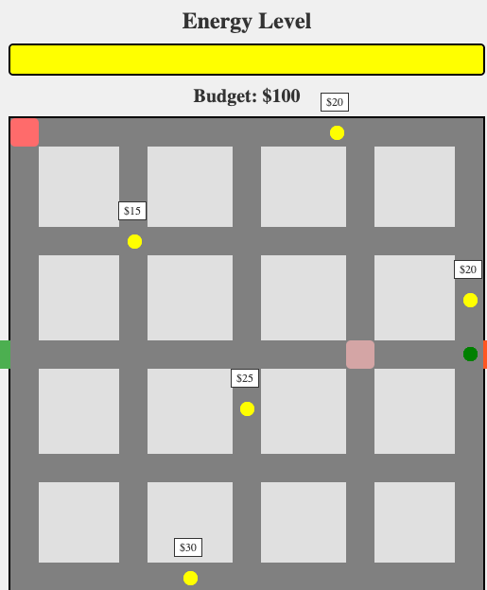
Task apperance

1. Conceptual Framework and Motivation

Problem Space:
Efficient allocation of limited resources (e.g., EV charging stations) presents significant challenges, especially with dynamic behavior and decision-making. This project studies human resource allocation decisions through a real-time, interactive online tool.

Key Innovations and Advantages:
- Real-Time Interaction: WebSockets provide synchronized, multi-user interactions.
- Customizability: A control panel dynamically adjusts parameters like station count, average prices, and player budgets.
- Integration: Player behavior and station selection data are stored in a MySQL database for analysis.

Future Development Roadmap:
- Enhanced visualization of player actions and system states.
- Integration of machine-learning models for behavior prediction.
- Expanded parameter customization for diverse experimental setups.

2. Architecture and Implementation

System Architecture:
The architecture comprises three main components:
- Client-Side Interface (HTML + JavaScript): Manages user interaction and displays the simulation using a dynamic game map.
- Server-Side Logic (Node.js + WebSocket): Manages connections, synchronizes game states, relays updates, and handles admin parameter changes.
- Database Layer (MySQL): Records player positions for post-experiment analysis.
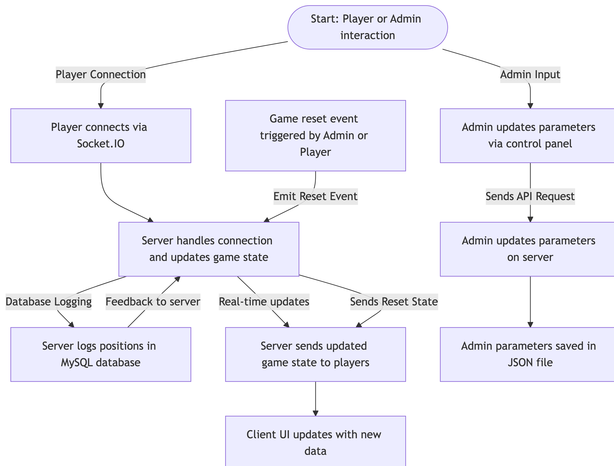
Figure 1: example diagram 1

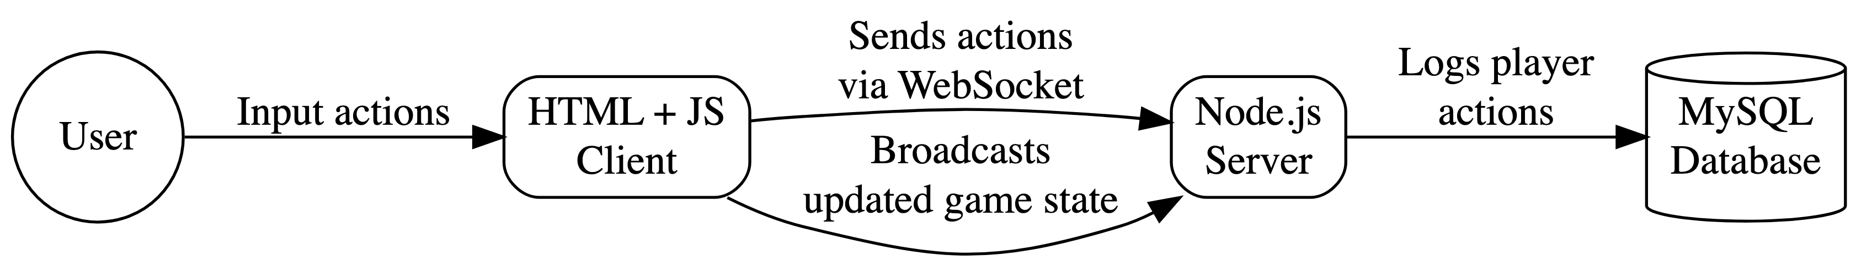
Figure 2: example diagram 2
Data Flow:
- Client connects to server via Socket.IO.
- Server sends initial game state (players, stations).
- Client renders the game.
- Player interacts (moves to a station).
- Client sends player’s action to the server.
- Server updates game state and broadcasts changes to all clients.
- Clients update displays.
- Player positions are periodically saved to MySQL.
Key Data Structures:
- gameState (Server): Holds game state (players, stations).
const gameState = {
players: new Map(), // Map of players and their attributes
stations: [
{ top: 8, left: 338, cost: 20 },
{ top: 479, left: 183, cost: 30 },
...
],
};
- Player Attributes:
  - Position (x, y)
  - Energy and monetary budgets
  - Assigned colors for visual distinction
- adminParameters (Client & Server): JSON with configurable parameters (station count, mean price, budget, download speed, station size).

3. Key Functions and Their Purpose
const setInitialParameters = async () => { ... }
Purpose: Retrieves initial game parameters from the server or defaults. Sets initial admin panel slider values.
updateButton.addEventListener('click', () => { ... });
Purpose: Sends updated parameters from the admin panel to the server.
const insertPlayerPosition = async (playerId, positionX, positionY) => { ... }
Purpose: Records player position in the MySQL database.
io.on('connection', (socket) => { ... });
Purpose: Handles new player connections, initializes player data, sends initial game state, manages movement/disconnections, and the game reset.
app.put('/admin-parameters', async (req, res) => { ... });
Purpose: Handles and validates incoming admin parameters. Updates AdminParams, saves to admin-data.json and sends parameter information to the players.

4. Key Features and Functionality

Feature 1: Synchronized Game State
- Real-time Interaction: Socket.IO enables responsive gameplay.
- Why: Ensures consistent user experience in multi-user settings.
- How: Employs WebSocket to propagate real-time updates.
1
io.on('connection', (socket) => {
const player = {
id: socket.id,
positionX: 0,
positionY: 235,
energy: 100,
money: 100,
color: getRandomColor(),
};
gameState.players.set(socket.id, player);
io.emit('gameState', gameState);
});

Feature 2: Dynamic Parameter Control
- Why: Facilitates experiment customization without server restarts.
- How: Parameters are adjustable via a control panel in the interface.
<label for="stationCount">Number of Stations:</label>
<input type="range" id="stationCount" min="1" max="20" value="5" />

Feature 3: Data Logging
- Why: Enables in-depth analysis of participant behavior.
- How: Logs player positions and actions into a MySQL database.
const insertPlayerPosition = async (playerId, positionX, positionY) => {
const query = `INSERT INTO player_positions (player_id, position_x, position_y) VALUES (?, ?, ?)`;
await mysqlConnection.execute(query, [playerId, positionX, positionY]);
};
- Admin Control Panel (admin.html): Dynamically adjusts parameters.
- Data Persistence (MySQL): Stores player data for analysis.
- Game Reset: Allows restarting from initial conditions.

5. Installation and Getting Started
- Install dependencies:
npm install express socket.io mysql2
- Start the server:
node server.js
- Open index.html: In a web browser.
- Open the Admin Control Panel: http://localhost:3000/admin

6. Limitations
- Matching Algorithms: Currently limited.
- Scalability: May require optimizations for large numbers of players.
- Game Logic: Requires more detailed implementation of energy, charging, and monetary mechanics.

7. Conclusion
This documentation outlines the structure and operation of the experiment software. Future work will focus on scalability, user experience, and integration with advanced analytics.

Appendix
2: Full server.js code.
import express from 'express';
import http from 'http';
import { Server } from 'socket.io';
import path from 'path';
import mysql from 'mysql2/promise';
import { fileURLToPath } from 'url';
import adminData from './admin-data.json' with { type: "json" };
import { writeFile } from 'fs/promises';
const __filename = fileURLToPath(import.meta.url);
const __dirname = path.dirname(__filename);
const app = express();
const server = http.createServer(app);
const io = new Server(server);
app.use(express.json())
let AdminParams = adminData;
// Configuración del puerto
const PORT = process.env.PORT || 3000;
const gameState = {
players: new Map(),
stations: [
{ top: 8, left: 338, cost: 20 },
{ top: 479, left: 183, cost: 30 },
{ top: 123, left: 124, cost: 15 },
{ top: 300, left: 243, cost: 25 },
{ top: 185, left: 479, cost: 10 },
],
};
let mysqlConnection;
const configureMySQL = async () => {
try {
mysqlConnection = await mysql.createConnection({
host: 'ec2-3-85-172-100.compute-1.amazonaws.com',
user: 'scastrom',
database: 'pathTracker',
password: 'samuel2024',
});
console.log('Conexión exitosa a MySQL');
} catch (err) {
console.error('Error al conectar a MySQL:', err.message);
}
};

